**Session-5 Assignment**

**Name: - Aryan Dilipbhai Langhanoja**

**Enroll No: - 92200133030**

**AIM**: To observe different Clipper, Clamper and Voltage multiplier circuits.

**Objective:**

1. To build and analyze various clipper circuits like biased and unbiased, series and shunt clipper.
2. To build and analyze positive and negative clamper.
3. To build and analyze voltage multiplier and its applications in CRTs, LASERs, X-ray systems. (High voltage low current)

**Outcome:** Students will be able to,

1. Analyze the effect of putting diode in series and shunt conditions.
2. Study the behavior of diode when connecting dc voltages in series with diode.
3. Analyze the effect of putting capacitor in diode circuits.
4. Develop the circuits of voltage multipliers as per requirements.

**Components and Apparatus in MultiSim:**

1. Diode 1N4007
2. 1000Ω Resistor
3. 100µF Capacitor
4. AC Signal Source
5. DC Power Supply
6. Oscilloscope

**Tasks: Series and Shunt Positive and Negative Clipper and Clamper Circuit: (simulate in Multisim)**

**Implement below circuit in MultiSim and observe output across resistor for each circuit. Consider Input voltage for each circuit as 10V (Vp-p) with frequency of 50Hz.**

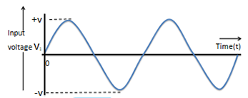

1. **Positive Series Clipper Circuit diagram:**

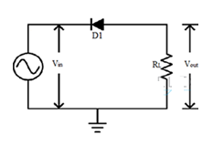

Simulation circuit in Multisim:

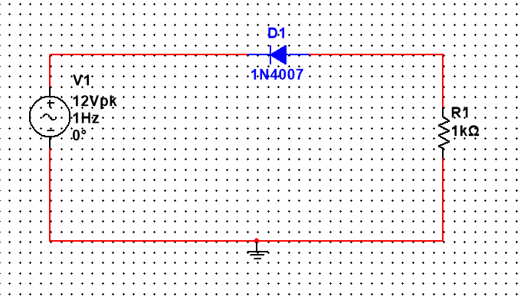

Input and output waveforms:

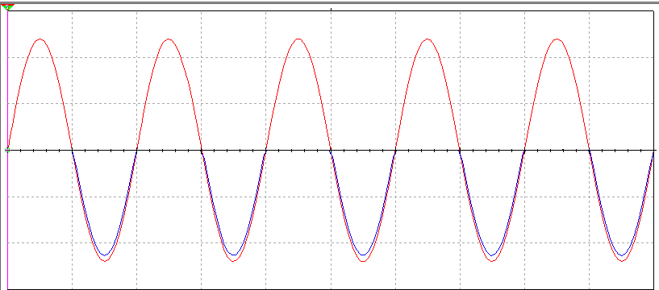

1. **Negative Series Clipper Circuit diagram:**

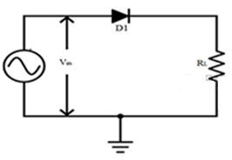

Simulation circuit in Multisim:

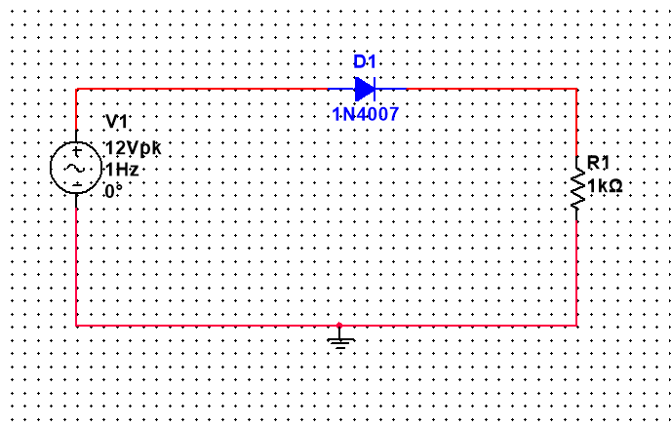

Input and output waveforms:

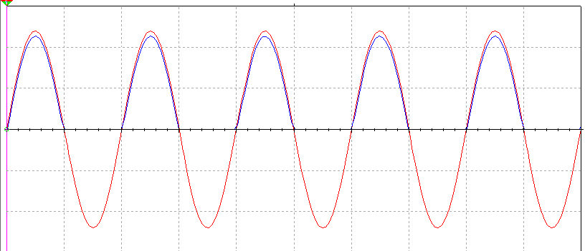

1. **Positive Shunt Clipper Circuit diagram:**

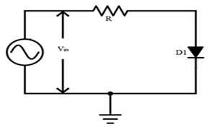

Simulation circuit in Multisim:

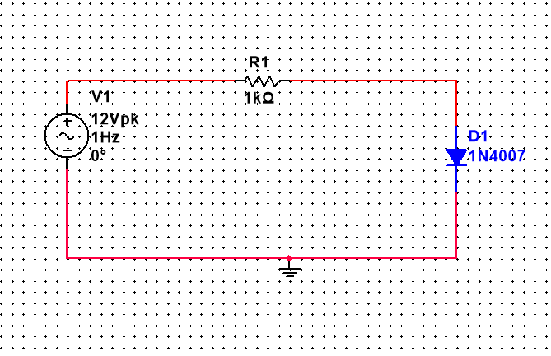

Input and output waveforms:

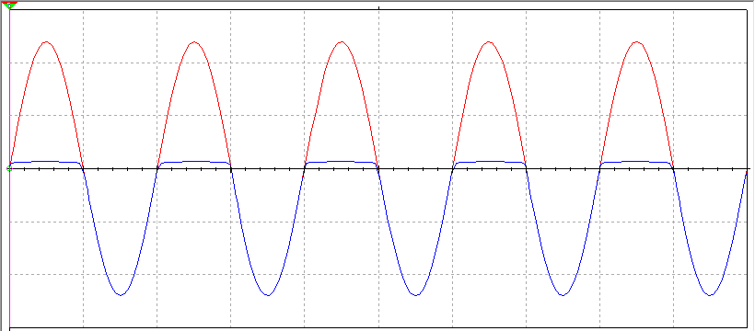

1. **Negative Shunt Circuit diagram:**

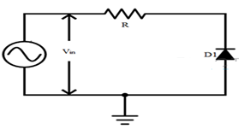

Simulation circuit in Multisim:

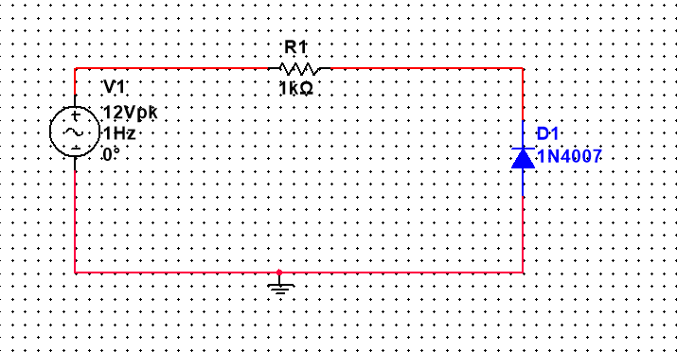

Input and output waveforms:

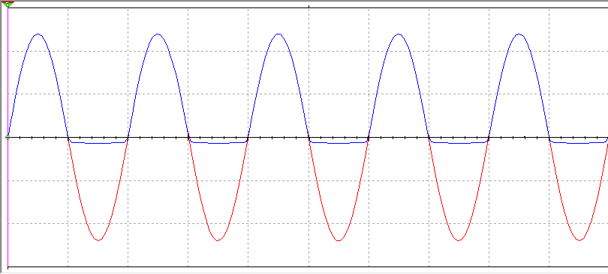

1. **Positive Series Biased Clipper Circuit diagram: (Vdc = 2V)**

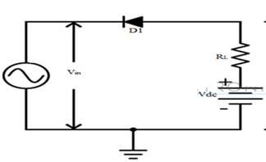

Simulation circuit in Multisim:

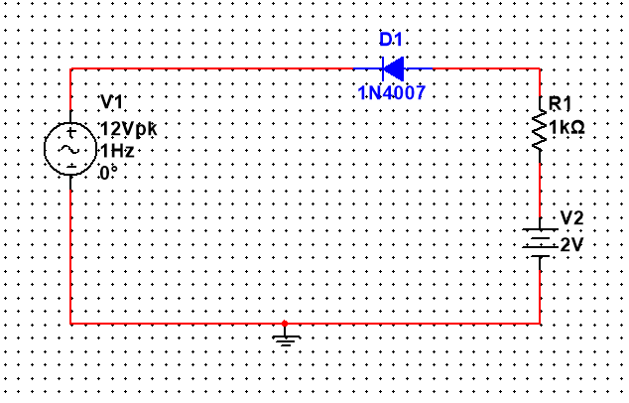

Input and output waveforms:

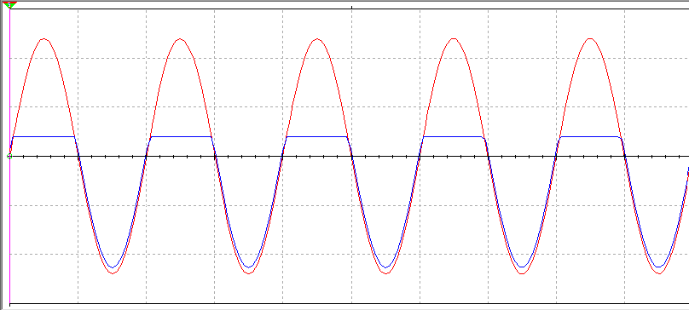

1. **Positive Series Biased Clipper Circuit diagram: (Vdc = 2V)**

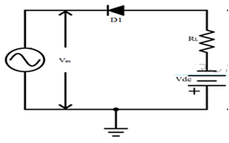

Simulation circuit in Multisim:

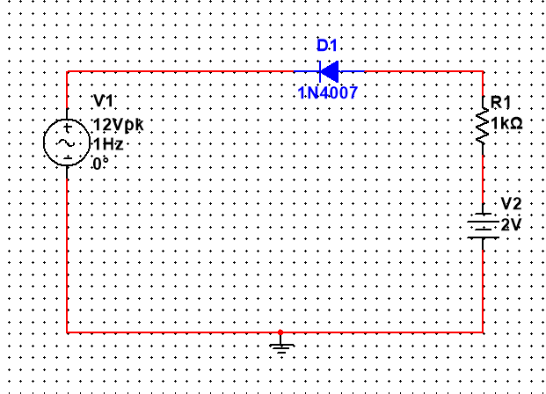

Input and output waveforms:

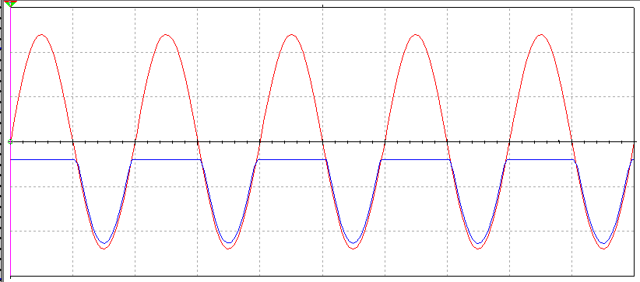

1. **Negative Series Biased Clipper Circuit diagram:(Vdc = 2V)**

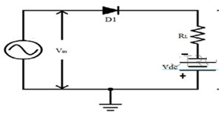

Simulation circuit in Multisim:

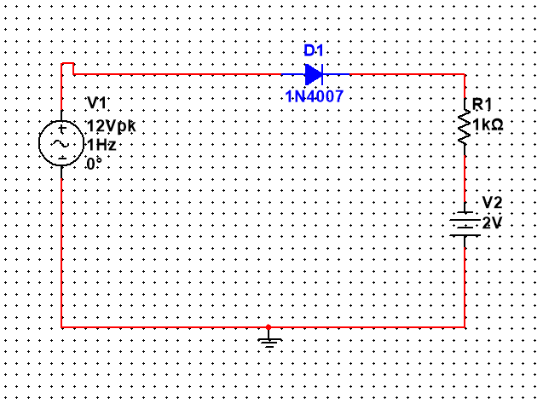

Input and output waveforms:

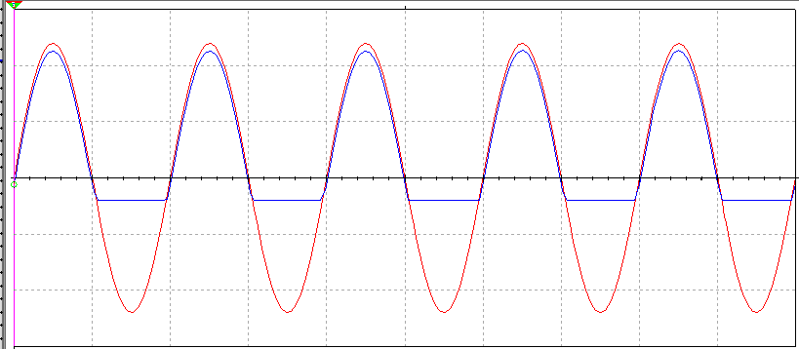

1. **Positive Shunt Biased Clipper Circuit diagram:(Vdc = 2V)**

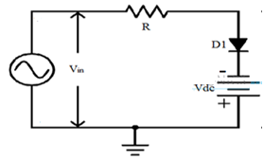

Simulation circuit in Multisim:

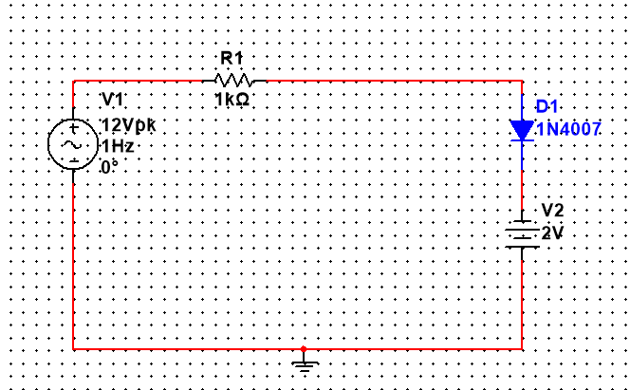

Input and output waveforms:



1. **Combinational Clipper Circuit diagram:(V1=2Vdc and V2=2Vdc)**

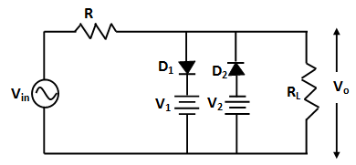

Simulation circuit in Multisim:

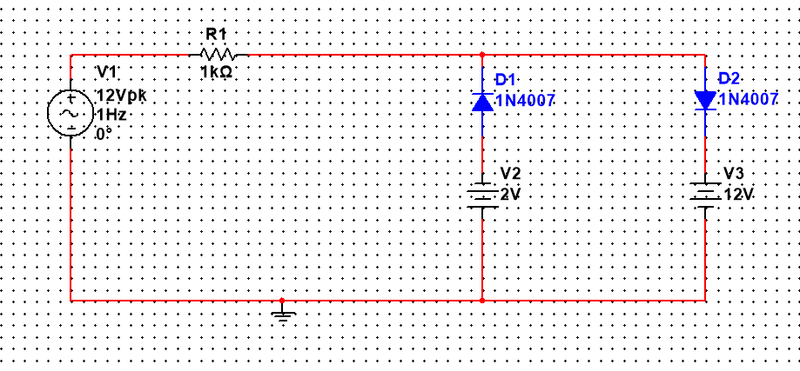

Input and output waveforms:

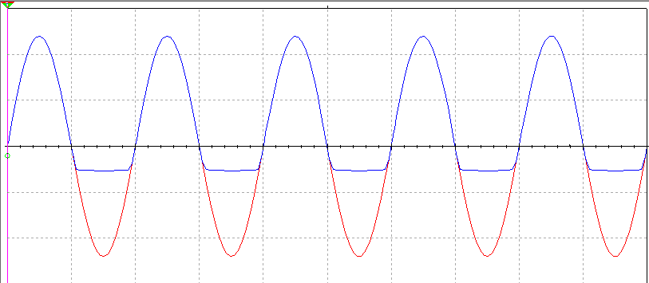

1. **Negative Clamper Circuit diagram:**

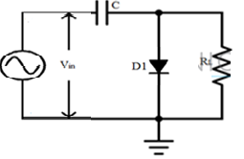

Simulation circuit in Multisim:

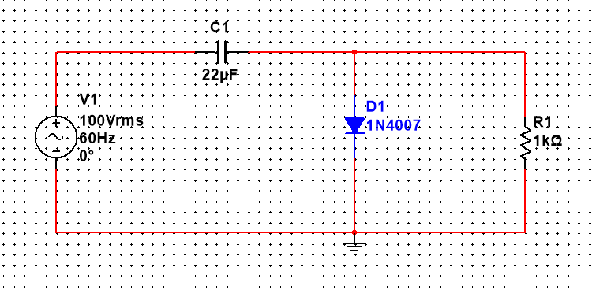

Input and output waveforms:

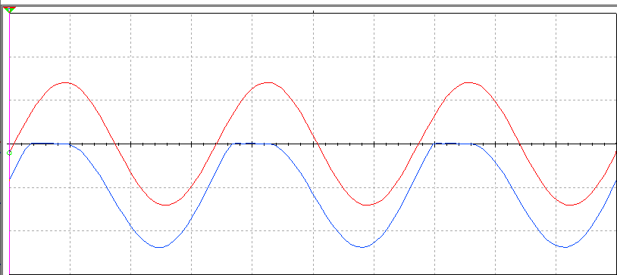

1. **Positive Clamper Circuit diagram:**

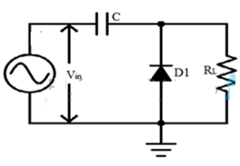

Simulation circuit in Multisim:

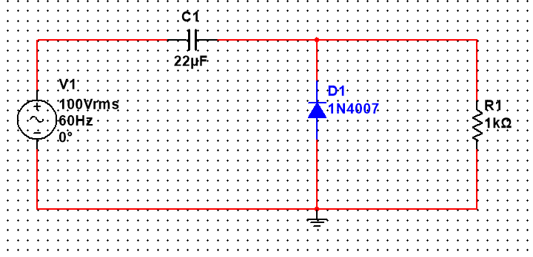

Input and output waveforms:

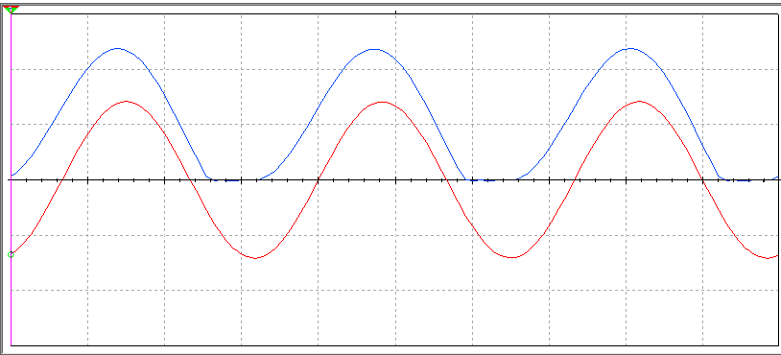

1. **Voltage Double Circuit diagram:**

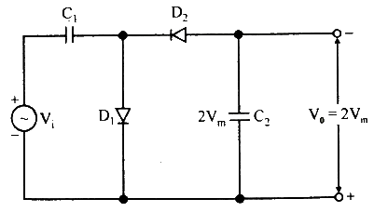

Simulation circuit in Multisim:

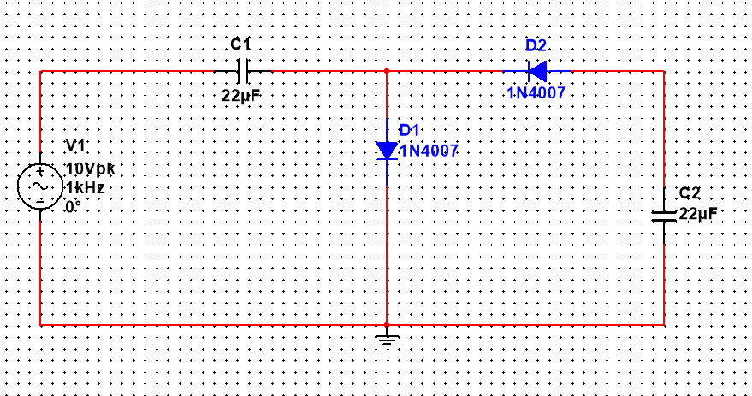

Input and output waveforms:

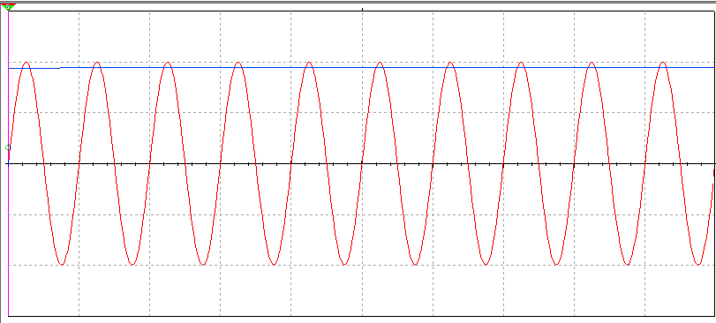

1. **VoltageTripler Circuit diagram:**

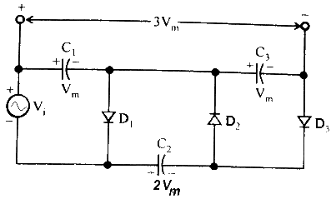

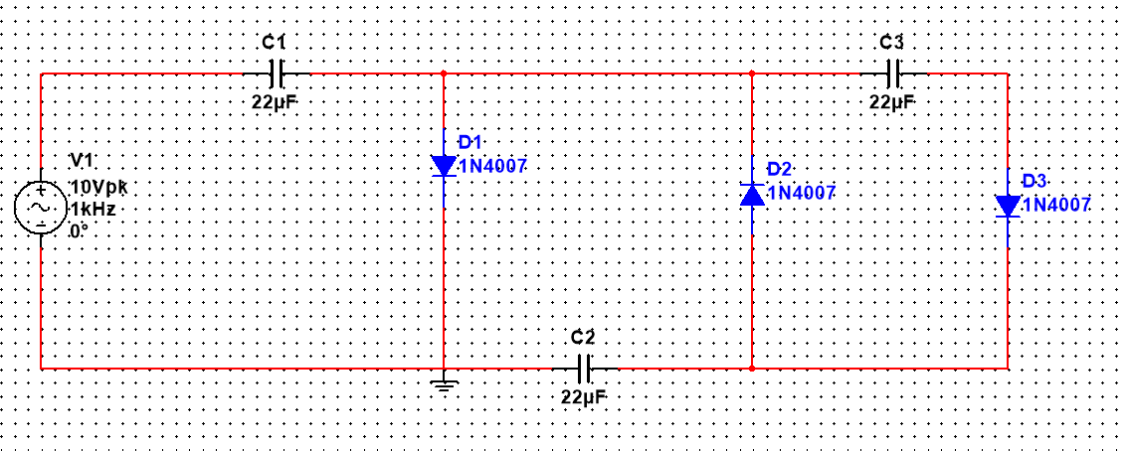Simulation circuit in Multisim:

Input and output waveforms:

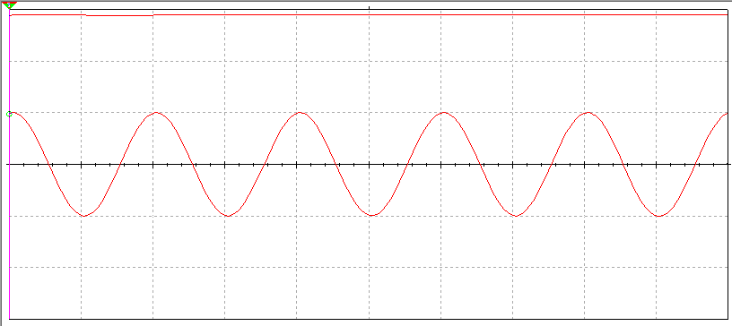

1. **Voltage Quadrupler Circuit diagram:**

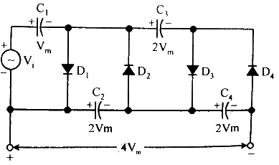

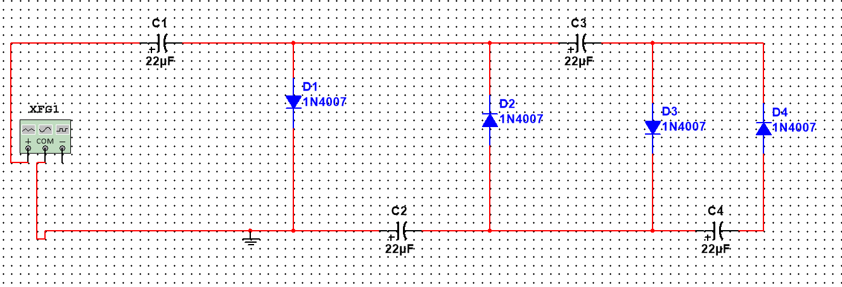Simulation circuit in Multisim:

Input and output waveforms:

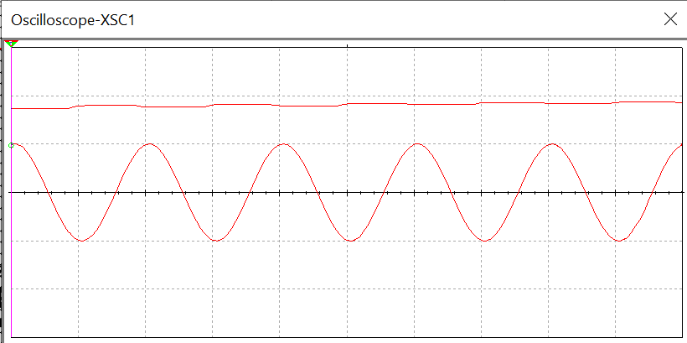

**Conclusion:**